Home page

Html coding:-

<html>

<head>

<title>Stationery</title>

<link rel="stylesheet" type="text/css" href="css/style.css">

</head>

<body>

<header>

<div id="navigation">

<nav>

<img src="logo1.png" width="250" height="100">

<ul>

<h1>

<li><a href="#">Home</a></li>

<li><a href="Service.html">Service</a></li>

<li><a href="gallery.html">Our Product</a></li>

<li><a href="Registration.html">Registration</a></li>

</h1>

</ul>

</nav>

<div id="slider">

<figure>

<img src="5.jpg" height="600px">

<img src="6.jpg" height="600px">

<img src="2.jpg" height="600px">

<img src="3.jpg" height="600px">

<img src="1.jpg" height="600px">

</figure>

</div>

</div>

</header>

<footer>

<font color="black">

<div align="center" class="imag">

<b><h1>Contact Us</h1></b><br><br>

<img src="facebook.jpg" width="40" height="40">&nbsp

<img src="instagram.png" width="40" height="40">&nbsp

<img src="twitter.png" width="40" height="40">

</div>

</font>

</footer>

</body>

</html>

Css coding:-

\*{

margin: 0;

padding: 0;

font-family: century Gathic;

}

#slider{

overflow: hidden;

}

#slider figure{

position: relative;

width: 500%;

margin: 0;

left: 0;

animation: 20s slider infinite;

}

#slider figure img{

width: 20%;

float: left;

}

@keyframes slider{

0%

{

left: 0%;

}

15%

{

left: 0%;

}

20%

{

left: -100%;

}

35%

{

left: -100%;

}

40%

{

left: -200%;

}

55%

{

left: -200%;

}

60%

{

left: -300%;

}

75%

{

left: -300%;

}

80%

{

left: -400%;

}

100%

{

left: -400%;

}

}

nav{

width: 100%;

height: 80px;

background-color: #fff;

line-height: 80px;

}

nav ul{

float: right;

margin-right: 30PX;

}

nav ul li{

list-style-type: none;

display: inline-block;

}

nav ul li:hover{

background-color: lightgrey;

transition: 0.8s all;

}

nav ul li a{

text-decoration: none;

color: #000;

padding: 30px;

}

nav img{

margin-left: 3%;

}

Output:-

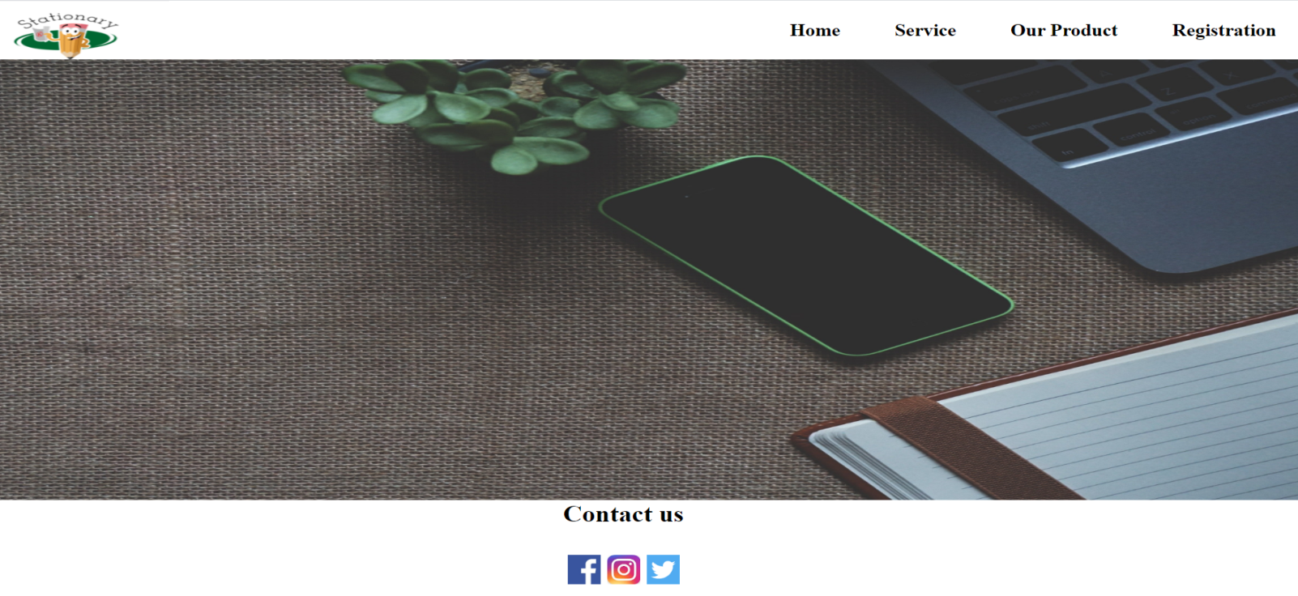









Our Product

Html coding:-

<!DOCTYPE html>

<html>

<head>

<title> gallery </title>

<link rel="stylesheet" type="text/css" href="css/gallery.css">

</head>

<body>

<div class="container">

<div class="image">

<div class="image1">

<img src="bag.jpg" height="250" width="330">

<h3><a href="bag.html"> Bags </a></h3>

</div>

</div>

<div class="image">

<div class="image1">

<img src="book9.jpg" height="250" width="330">

<h3><a href="book.html"> Books </a></h3>

</div>

</div>

<div class="image">

<div class="image1">

<img src="camm.jpg" height="320" width="330">

<h3><a href="cam.html"> Campass Box </a></h3>

</div>

</div>

<div class="image">

<div class="image1">

<img src="lunch.jpg" height="380" width="379">

<h3><a href="lunch.html"> Lunch Box </a></h3>

</div>

</div>

<div class="image">

<div class="image1">

<img src="file.jpg" height="380" width="379">

<h3><a href="file.html"> Files</a></h3>

</div>

</div>

<div class="image">

<div class="image1">

<img src="water1.jpg" height="380" width="379">

<h3><a href="water.html"> Water bags</a></h3>

</div>

</div>

</div>

<footer>

<font color="black">

<div align="center" class="imag">

<b><h1>Contact Us</h1></b><br><br>

<img src="facebook.jpg" width="40" height="40">&nbsp

<img src="instagram.png" width="40" height="40">&nbsp

<img src="twitter.png" width="40" height="40">

</div>

</font>

</footer>

</body>

</html>

Css coding:-

body{

margin: 0;

padding: 0;

background-color: grey;

}

.container{

width: 1280px;

height: 900px;

margin: 50px auto 0;

display: flex;

flex-direction: row;

flex-wrap: wrap;

}

.container .image{

position: relative;

width: 370px;

height: 400px;

margin: 15px;

box-sizing: border-box;

display: inline-block;

}

.container .image .image1{

position: relative;

border-radius: 35px;

overflow: hidden;

border:1px solid #eee;

}

.container .image .image1 img{

max-width: 100%;

height: 100%;

width:100%;

transition: transform 2s;

}

.container .image:hover .image1 img{

transform: scale(1.2);

border-radius: 35px;

}

.image{

position:relative;

}

.image h3 a{

position:absolute;

left:0;

top:0;

bottom:0;

right:0;

display:flex;

align-items:center;

justify-content: center;

font-family: arial;

color: #ff0000;

font-size:28px;

background: rgba(0,0,0,0.2);

opacity: 0;

transform:scale(2);

margin:0;

transition:all 0.5s;

text-decoration: none;

height:36px;

width: 94%;

background: rgba(0,0,0,0.7);

margin-left:0%;

margin-top:48%;

color: #fff;

border:none;

border-bottom-left-radius:16px;

border-bottom-right-radius:16px;

padding: 3%;

text-align: center;

}

.image:hover h3 a{

opacity: 1;

transform:scale(1);

}

a{

text-decoration: none;

font-size: 16px;

}

a h1{

margin-top: 10px;

margin-right: 35px;

text-align: right;

}

a h1:hover{

color: #ff6666;

}

Output:-

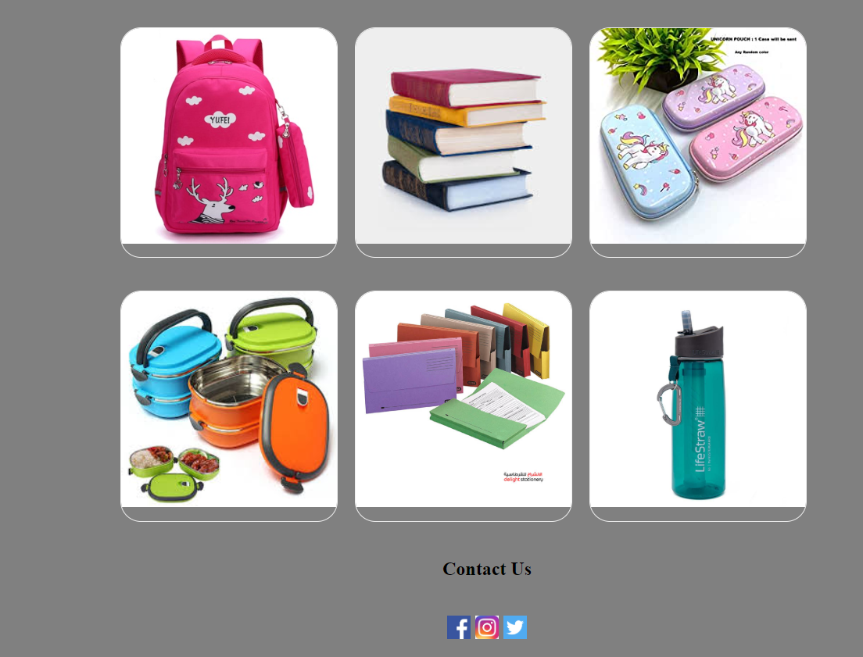

Bag

Html coding:

<!DOCTYPE html>

<html>

<head>

<title> bag</title>

<link rel="stylesheet" type="text/css" href="css/bag.css">

</head>

<body>

<div class="container">

<div class="bag">

<div align="center" class="bag1">

<img src="bag10.jpeg" height="380" width="379"><br><br>

<h5>Bag</h5>

<h4>

<small><s>600</s></small>

<span>450</span>

</h4>

<input type="button" name="addtocart" value="Add to Cart">

<h3><a href="#"></a></h3>

</div>

</div>

<div class="bag">

<div align="center" class="bag1">

<img src="bag11.jpg" height="380" width="379"><br><br>

<h5>Bag</h5>

<h4>

<small><s>650</s></small>

<span>500</span>

</h4>

<input type="button" name="addtocart" value="Add to Cart">

<h3><a href="#"></a></h3>

</div>

</div>

<div class="bag">

<div align="center" class="bag1">

<img src="bag12.jpg" height="380" width="379"><br><br>

<h5>Bag</h5>

<h4>

<small><s>700</s></small>

<span>600</span>

</h4>

<input type="button" name="addtocart" value="Add to Cart">

<h3><a href="#"></a></h3>

</div>

</div>

<div class="bag">

<div align="center" class="bag1">

<img src="bag4.jpeg" height="380" width="379"><br><br>

<h5>Bag</h5>

<h4>

<small><s>500</s></small>

<span>450</span>

</h4>

<input type="button" name="addtocart" value="Add to Cart">

<h3><a href="#"></a></h3>

</div>

</div>

<div class="bag">

<div align="center" class="bag1">

<img src="bag5.jpg" height="380" width="379"><br><br>

<h5>Bag</h5>

<h4>

<small><s>700</s></small>

<span>650</span>

</h4>

<input type="button" name="addtocart" value="Add to Cart">

<h3><a href="#"></a></h3>

</div>

</div>

<div class="bag">

<div align="center" class="bag1">

<img src="bag6.jpg" height="380" width="379"><br><br>

<h5>Bag</h5>

<h4>

<small><s>800</s></small>

<span>700</span>

</h4>

<input type="button" name="addtocart" value="Add to Cart">

<h3><a href="#"></a></h3>

</div>

</div>

<div class="bag">

<div align="center" class="bag1">

<img src="bag13.jpeg" height="380" width="379"><br><br>

<h5>Bag</h5>

<h4>

<small><s>750</s></small>

<span>650</span>

</h4>

<input type="button" name="addtocart" value="Add to Cart">

<h3><a href="#"></a></h3>

</div>

</div>

<div class="bag">

<div align="center" class="bag1">

<img src="bag14.png" height="380" width="379"><br><br>

<h5>Bag</h5>

<h4>

<small><s>500</s></small>

<span>450</span>

</h4>

<input type="button" name="addtocart" value="Add to Cart">

<h3><a href="#"></a></h3>

</div>

</div>

<div class="bag">

<div align="center" class="bag1">

<img src="bag9.jpg" height="380" width="379"><br><br>

<h5>Bag</h5>

<h4>

<small><s>600</s></small>

<span>550</span>

</h4>

<input type="button" name="addtocart" value="Add to Cart">

<h3><a href="#"></a></h3>

</div>

</div>

</div>

</body>

</html>

Css coding:-

body{

margin: 0;

padding: 0;

background-color: grey;

}

.container{

width: 1280px;

height: 900px;

margin: 50px auto 0;

display: flex;

flex-direction: row;

flex-wrap: wrap;

}

.container .bag{

position: relative;

width: 370px;

height: 550px;

margin: 15px;

box-sizing: border-box;

display: inline-block;

}

.container .bag .bag1{

position: relative;

border-radius: 35px;

overflow: hidden;

border:1px solid #eee;

}

.container .bag.bag1 img{

max-width: 100%;

height: 100%;

width:100%;

transition: transform 2s;

}

.container .bag:hover .bag1 img{

transform: scale(1.2);

border-radius: 35px;

}

.bag{

position:relative;

}

.bag h3 a{

position:absolute;

left:0;

top:0;

bottom:0;

right:0;

display:flex;

align-items:center;

justify-content: center;

font-family: arial;

color: #ff0000;

font-size:28px;

background: rgba(0,0,0,0);

opacity: 0;

transform:scale(2);

margin:0;

transition:all 0.5s;

text-decoration: none;

height:36px;

width: 94%;

background: rgba(0,0,0,0);

margin-left:0%;

margin-top:48%;

color: #fff;

border:none;

border-bottom-left-radius:16px;

border-bottom-right-radius:16px;

padding: 3%;

text-align: center;

}

.bag:hover h3 a{

opacity: 1;

transform:scale(1);

}

a{

text-decoration: none;

font-size: 16px;

}

a h1{

margin-top: 10px;

margin-right: 35px;

text-align: right;

}

a h1:hover{

color: #ff6666;

}

Output:-

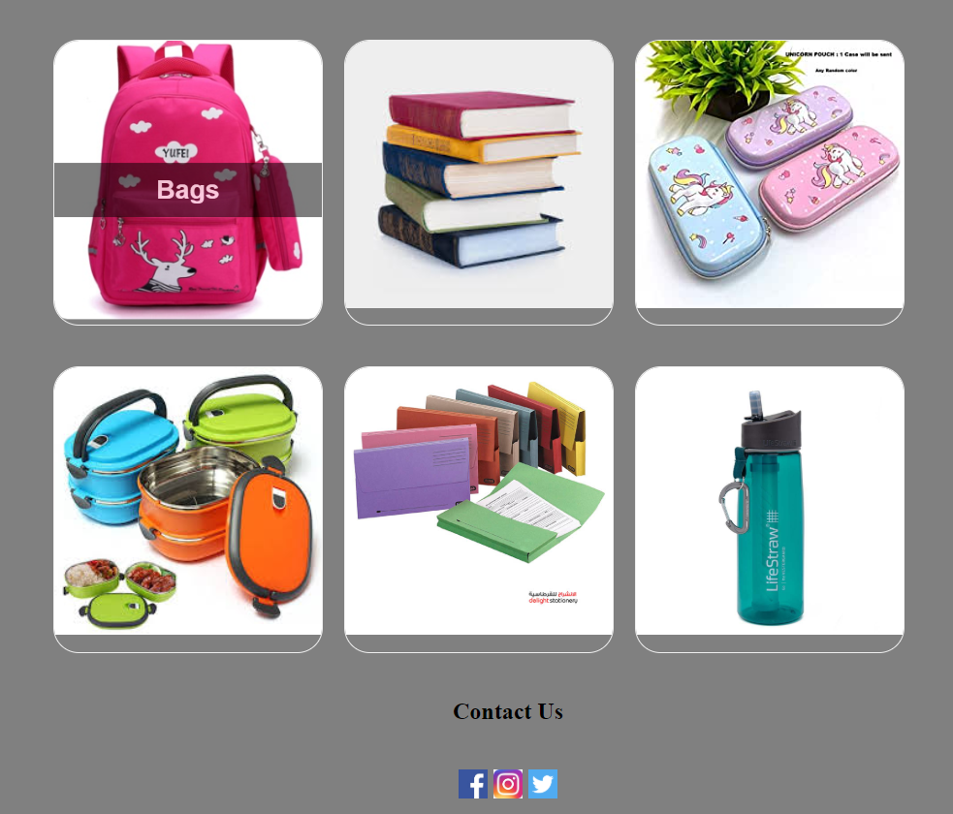

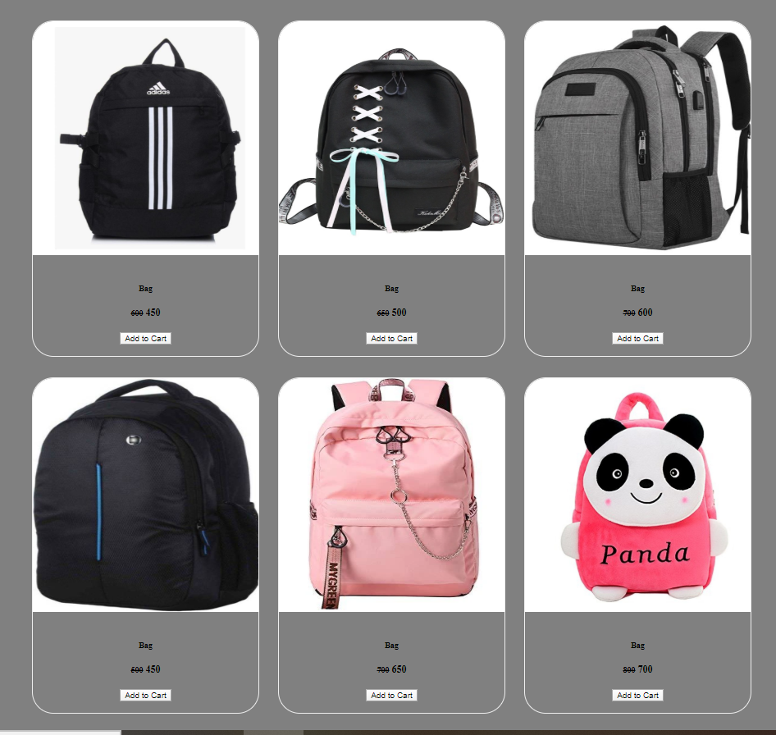

Book

Html coding:-

<!DOCTYPE html>

<html>

<head>

<title> book </title>

<link rel="stylesheet" type="text/css" href="css/book.css">

</head>

<body>

<div class="container">

<div class="book">

<div align="center" class="book1">

<img src="book1.jpg" height="380" width="350"><br><br>

<h5>Book</h5>

<h4>

<small><s>100</s></small>

<span>80</span>

</h4>

<input type="button" name="addtocart" value="Add to Cart">

<h3><a href="#"></a></h3>

</div>

</div>

<div class="book">

<div align="center" class="book1">

<img src="book2.jpg" height="380" width="350"><br><br>

<h5>Book</h5>

<h4>

<small><s>120</s></small>

<span>80</span>

</h4>

<input type="button" name="addtocart" value="Add to Cart">

<h3><a href="#"></a></h3>

</div>

</div>

<div class="book">

<div align="center" class="book1">

<img src="book3.jpeg" height="380" width="350"><br><br>

<h5>Book</h5>

<h4>

<small><s>80</s></small>

<span>60</span>

</h4>

<input type="button" name="addtocart" value="Add to Cart">

<h3><a href="#"></a></h3>

</div>

</div>

<div class="book">

<div align="center" class="book1">

<img src="book4.jpg" height="380" width="350"><br><br>

<h5>Book</h5>

<h4>

<small><s>100</s></small>

<span>70</span>

</h4>

<input type="button" name="addtocart" value="Add to Cart">

<h3><a href="#"></a></h3>

</div>

</div>

<div class="book">

<div align="center" class="book1">

<img src="book5.png" height="380" width="350"><br><br>

<h5>Book</h5>

<h4>

<small><s>120</s></small>

<span>90</span>

</h4>

<input type="button" name="addtocart" value="Add to Cart">

<h3><a href="#"></a></h3>

</div>

</div>

<div class="book">

<div align="center" class="book1">

<img src="book6.jpeg" height="380" width="350"><br><br>

<h5>Book</h5>

<h4>

<small><s>90</s></small>

<span>80</span>

</h4>

<input type="button" name="addtocart" value="Add to Cart">

<h3><a href="#"></a></h3>

</div>

</div>

<div class="book">

<div align="center" class="book1">

<img src="book7.jpg" height="380" width="350"><br><br>

<h5>Book</h5>

<h4>

<small><s>90</s></small>

<span>70</span>

</h4>

<input type="button" name="addtocart" value="Add to Cart">

<h3><a href="#"></a></h3>

</div>

</div>

<div class="book">

<div align="center" class="book1">

<img src="book8.jpg" height="380" width="350"><br><br>

<h5>Book</h5>

<h4>

<small><s>100</s></small>

<span>80</span>

</h4>

<input type="button" name="addtocart" value="Add to Cart">

<h3><a href="#"></a></h3>

</div>

</div>

<div class="book">

<div align="center" class="book1">

<img src="book9.jpg" height="380" width="350"><br><br>

<h5>Book</h5>

<h4>

<small><s>80</s></small>

<span>70</span>

</h4>

<input type="button" name="addtocart" value="Add to Cart">

<h3><a href="#"></a></h3>

</div>

</div>

</div>

</body>

</html>

Css coding:-

body{

margin: 0;

padding: 0;

background-color: grey;

}

.container{

width: 1280px;

height: 900px;

margin: 50px auto 0;

display: flex;

flex-direction: row;

flex-wrap: wrap;

}

.container .book{

position: relative;

width: 370px;

height: 550px;

margin: 15px;

box-sizing: border-box;

display: inline-block;

}

.container .book.book1{

position: relative;

border-radius: 35px;

overflow: hidden;

border:1px solid #eee;

}

.container .book.book1 img{

max-width: 100%;

height: 100%;

width:100%;

transition: transform 2s;

}

.container .book:hover .book1 img{

transform: scale(1.2);

border-radius: 35px;

}

.book{

position:relative;

}

.book h3 a{

position:absolute;

left:0;

top:0;

bottom:0;

right:0;

display:flex;

align-items:center;

justify-content: center;

font-family: arial;

color: #ff0000;

font-size:28px;

background: rgba(0,0,0,0);

opacity: 0;

transform:scale(2);

margin:0;

transition:all 0.5s;

text-decoration: none;

height:36px;

width: 94%;

background: rgba(0,0,0,0);

margin-left:0%;

margin-top:48%;

color: #fff;

border:none;

border-bottom-left-radius:16px;

border-bottom-right-radius:16px;

padding: 3%;

text-align: center;

}

.book:hover h3 a{

opacity: 1;

transform:scale(1);

}

a{

text-decoration: none;

font-size: 16px;

}

a h1{

margin-top: 10px;

margin-right: 35px;

text-align: right;

}

a h1:hover{

color: #ff6666;

}

Output:-

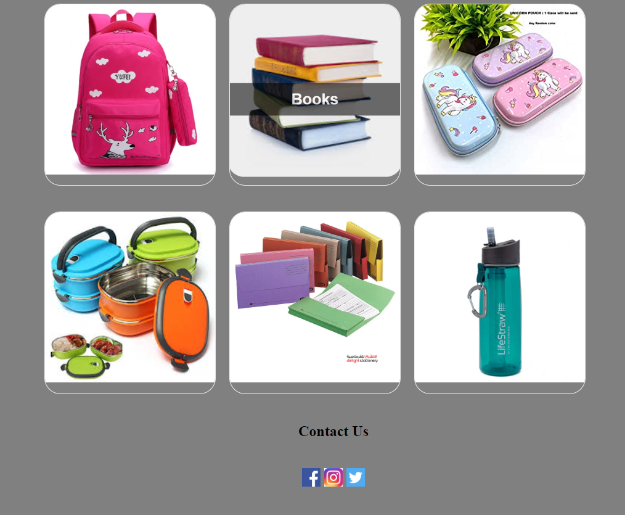

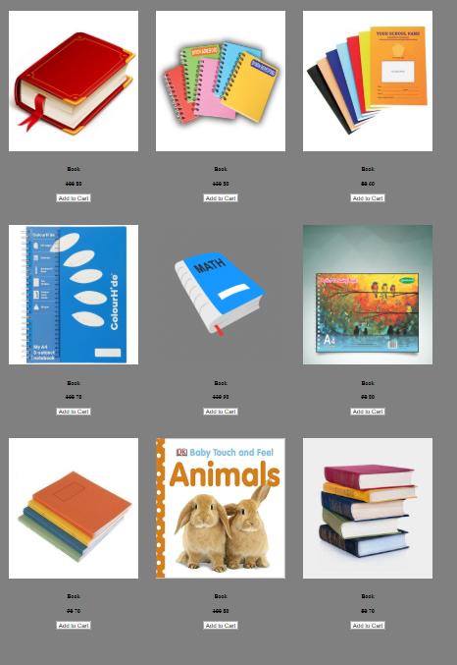

Compass Box

Html coding:-

<!DOCTYPE html>

<html>

<head>

<title> cam </title>

<link rel="stylesheet" type="text/css" href="css/cam.css">

</head>

<body>

<div class="container">

<div class="cam">

<div align="center" class="cam1">

<img src="cam1.jpg" height="320" width="350"><br><br>

<h5>Compass box</h5>

<h4>

<small><s>200</s></small>

<span>100</span>

</h4>

<input type="button" name="addtocart" value="Add to Cart">

<h3><a href="#"></a></h3>

</div>

</div>

<div class="cam">

<div align="center" class="cam1">

<img src="cam2.jpg" height="320" width="350"><br><br>

<h5> Compass box </h5>

<h4>

<small><s>400</s></small>

<span>300</span>

</h4>

<input type="button" name="addtocart" value="Add to Cart">

<h3><a href="#"></a></h3>

</div>

</div>

<div class="cam">

<div align="center" class="cam1">

<img src="cam3.jpg" height="320" width="350"><br><br>

<h5> Compass box </h5>

<h4>

<small><s>100</s></small>

<span>70</span>

</h4>

<input type="button" name="addtocart" value="Add to Cart">

<h3><a href="#"></a></h3>

</div>

</div>

<div class="cam">

<div align="center" class="cam1">

<img src="cam4.jpg" height="320" width="350"><br><br>

<h5> Compass box </h5>

<h4>

<small><s>300</s></small>

<span>180</span>

</h4>

<input type="button" name="addtocart" value="Add to Cart">

<h3><a href="#"></a></h3>

</div>

</div>

<div class="cam">

<div align="center" class="cam1">

<img src="cam5.jpg" height="320" width="350"><br><br>

<h5> Compass box </h5>

<h4>

<small><s>200</s></small>

<span>180</span>

</h4>

<input type="button" name="addtocart" value="Add to Cart">

<h3><a href="#"></a></h3>

</div>

</div>

<div class="cam">

<div align="center" class="cam1">

<img src="cam6.jpeg" height="320" width="350"><br><br>

<h5> Compass box </h5>

<h4>

<small><s>250</s></small>

<span>180</span>

</h4>

<input type="button" name="addtocart" value="Add to Cart">

<h3><a href="#"></a></h3>

</div>

</div>

<div class="cam">

<div align="center" class="cam1">

<img src="cam7.jpg" height="320" width="350"><br><br>

<h5> Compass box </h5>

<h4>

<small><s>400</s></small>

<span>350</span>

</h4>

<input type="button" name="addtocart" value="Add to Cart">

<h3><a href="#"></a></h3>

</div>

</div>

<div class="cam">

<div align="center" class="cam1">

<img src="cam8.jpg" height="320" width="350"><br><br>

<h5> Compass box </h5>

<h4>

<small><s>340</s></small>

<span>280</span>

</h4>

<input type="button" name="addtocart" value="Add to Cart">

<h3><a href="#"></a></h3>

</div>

</div>

<div class="cam">

<div align="center" class="cam1">

<img src="cam9.jpg" height="320" width="350"><br><br>

<h5> Compass box </h5>

<h4>

<small><s>250</s></small>

<span>170</span>

</h4>

<input type="button" name="addtocart" value="Add to Cart">

<h3><a href="#"></a></h3>

</div>

</div>

</div>

</body>

</html>

Css coding:-

body{

margin: 0;

padding: 0;

background-color: grey;

}

.container{

width: 1280px;

height: 900px;

margin: 50px auto 0;

display: flex;

flex-direction: row;

flex-wrap: wrap;

}

.container .cam{

position: relative;

width: 370px;

height: 550px;

margin: 15px;

box-sizing: border-box;

display: inline-block;

}

.container .cam.cam1{

position: relative;

border-radius: 35px;

overflow: hidden;

border:1px solid #eee;

}

.container .cam.cam1 img{

max-width: 100%;

height: 100%;

width:100%;

transition: transform 2s;

}

.container .cam:hover .cam1 img{

transform: scale(1.2);

border-radius: 35px;

}

.cam{

position:relative;

}

.cam h3 a{

position:absolute;

left:0;

top:0;

bottom:0;

right:0;

display:flex;

align-items:center;

justify-content: center;

font-family: arial;

color: #ff0000;

font-size:28px;

background: rgba(0,0,0,0);

opacity: 0;

transform:scale(2);

margin:0;

transition:all 0.5s;

text-decoration: none;

height:36px;

width: 94%;

background: rgba(0,0,0,0);

margin-left:0%;

margin-top:48%;

color: #fff;

border:none;

border-bottom-left-radius:16px;

border-bottom-right-radius:16px;

padding: 3%;

text-align: center;

}

.cam:hover h3 a{

opacity: 1;

transform:scale(1);

}

a{

text-decoration: none;

font-size: 16px;

}

a h1{

margin-top: 10px;

margin-right: 35px;

text-align: right;

}

a h1:hover{

color: #ff6666;

}

Output:-

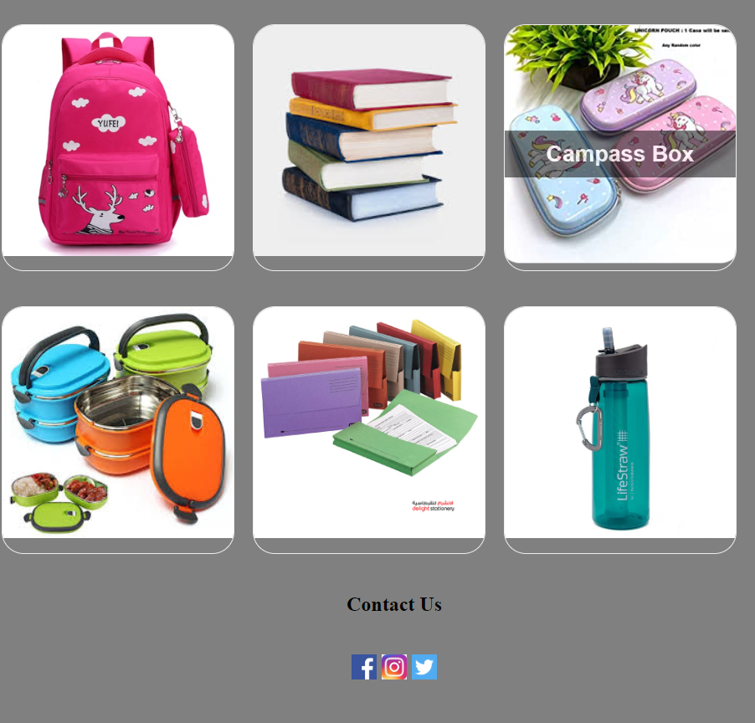

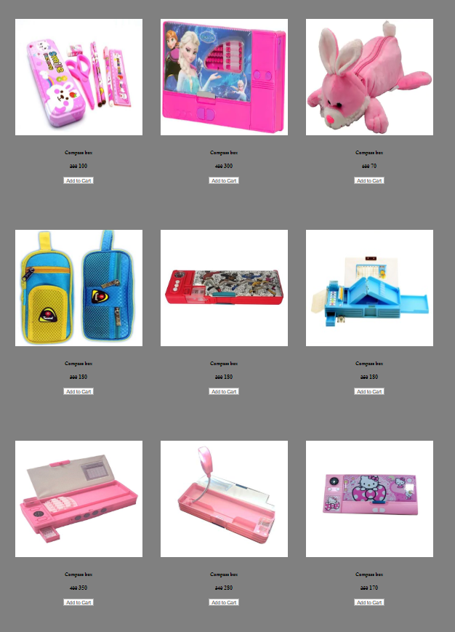

Lunch Box

Html coding:-

<!DOCTYPE html>

<html>

<head>

<title> lunch </title>

<link rel="stylesheet" type="text/css" href="css/lunch.css">

</head>

<body>

<div class="container">

<div class="lunch">

<div align="center" class="lunch1">

<img src="lunch1.jpg" height="320" width="379"><br><br>

<h5>Lunch box </h5>

<h4>

<small><s>200</s></small>

<span>150</span>

</h4>

<input type="button" name="addtocart" value="Add to Cart">

<h3><a href="#"></a></h3>

</div>

</div>

<div class="lunch">

<div align="center" class="lunch1">

<img src="lunch2.jpg" height="320" width="379"><br><br>

<h5> Lunch box </h5>

<h4>

<small><s>250</s></small>

<span>200</span>

</h4>

<input type="button" name="addtocart" value="Add to Cart">

<h3><a href="#"></a></h3>

</div>

</div>

<div class="lunch">

<div align="center" class="lunch1">

<img src="lunch3.jpg" height="320" width="379"><br><br>

<h5> Lunch box </h5>

<h4>

<small><s>300</s></small>

<span>280</span>

</h4>

<input type="button" name="addtocart" value="Add to Cart">

<h3><a href="#"></a></h3>

</div>

</div>

<div class="lunch">

<div align="center" class="lunch1">

<img src="lunch4.jpg" height="320" width="379"><br><br>

<h5> Lunch box </h5>

<h4>

<small><s>200</s></small>

<span>170</span>

</h4>

<input type="button" name="addtocart" value="Add to Cart">

<h3><a href="#"></a></h3>

</div>

</div>

<div class="lunch">

<div align="center" class="lunch1">

<img src="lunch5.jpg" height="320" width="379"><br><br>

<h5> Lunch box </h5>

<h4>

<small><s>250</s></small>

<span>200</span>

</h4>

<input type="button" name="addtocart" value="Add to Cart">

<h3><a href="#"></a></h3>

</div>

</div>

<div class="lunch">

<div align="center" class="lunch1">

<img src="lunch6.jpg" height="320" width="379"><br><br>

<h5> Lunch box </h5>

<h4>

<small><s>350</s></small>

<span>300</span>

</h4>

<input type="button" name="addtocart" value="Add to Cart">

<h3><a href="#"></a></h3>

</div>

</div>

<div class="lunch">

<div align="center" class="lunch1">

<img src="lunch7.jpg" height="320" width="379"><br><br>

<h5> Lunch box </h5>

<h4>

<small><s>200</s></small>

<span>170</span>

</h4>

<input type="button" name="addtocart" value="Add to Cart">

<h3><a href="#"></a></h3>

</div>

</div>

<div class="lunch">

<div align="center" class="lunch1">

<img src="lunch8.jpg" height="320" width="379"><br><br>

<h5> Lunch box </h5>

<h4>

<small><s>300</s></small>

<span>260</span>

</h4>

<input type="button" name="addtocart" value="Add to Cart">

<h3><a href="#"></a></h3>

</div>

</div>

<div class="lunch">

<div align="center" class="lunch1">

<img src="lunch10.jpg" height="320" width="379"><br><br>

<h5> Lunch box </h5>

<h4>

<small><s>300</s></small>

<span>280</span>

</h4>

<input type="button" name="addtocart" value="Add to Cart">

<h3><a href="#"></a></h3>

</div>

</div>

</div>

</body>

</html>

Css coding:-

body{

margin: 0;

padding: 0;

background-color: grey;

}

.container{

width: 1280px;

height: 900px;

margin: 50px auto 0;

display: flex;

flex-direction: row;

flex-wrap: wrap;

}

.container .lunch{

position: relative;

width: 370px;

height: 550px;

margin: 15px;

box-sizing: border-box;

display: inline-block;

}

.container .lunch .lunch1{

position: relative;

border-radius: 35px;

overflow: hidden;

border:1px solid #eee;

}

.container .lunch .lunch1 img{

max-width: 100%;

height: 100%;

width:100%;

transition: transform 2s;

}

.container .lunch:hover .lunch1 img{

transform: scale(1.2);

border-radius: 35px;

}

.lunch{

position:relative;

}

.lunch h3 a{

position:absolute;

left:0;

top:0;

bottom:0;

right:0;

display:flex;

align-items:center;

justify-content: center;

font-family: arial;

color: #ff0000;

font-size:28px;

background: rgba(0,0,0,0);

opacity: 0;

transform:scale(2);

margin:0;

transition:all 0.5s;

text-decoration: none;

height:36px;

width: 94%;

background: rgba(0,0,0,0);

margin-left:0%;

margin-top:48%;

color: #fff;

border:none;

border-bottom-left-radius:16px;

border-bottom-right-radius:16px;

padding: 3%;

text-align: center;

}

.lunch:hover h3 a{

opacity: 1;

transform:scale(1);

}

a{

text-decoration: none;

font-size: 16px;

}

a h1{

margin-top: 10px;

margin-right: 35px;

text-align: right;

}

a h1:hover{

color: #ff6666;

}

Output:-



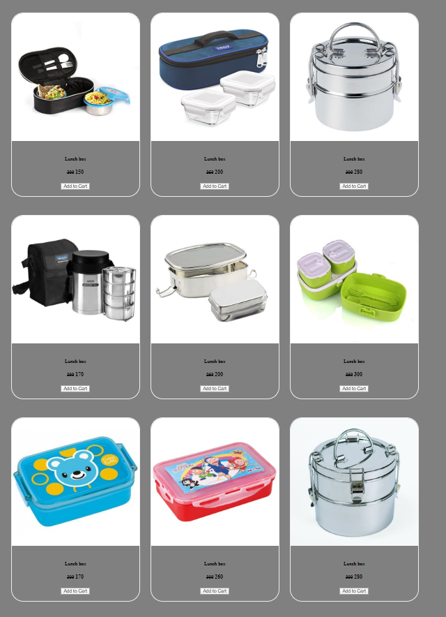

File

Html coding:-

<!DOCTYPE html>

<html>

<head>

<title> file </title>

<link rel="stylesheet" type="text/css" href="css/file.css">

</head>

<body>

<div class="container">

<div class="file">

<div align="center" class="file1">

<img src="file1.jpg" height="320" width="379"><br><br>

<h5>file </h5>

<h4>

<small><s>120</s></small>

<span>100</span>

</h4>

<input type="button" name="addtocart" value="Add to Cart">

<h3><a href="#"></a></h3>

</div>

</div>

<div class="file">

<div align="center" class="file1">

<img src="file10.jpg" height="320" width="379"><br><br>

<h5>file </h5>

<h4>

<small><s>140</s></small>

<span>120</span>

</h4>

<input type="button" name="addtocart" value="Add to Cart">

<h3><a href="#"></a></h3>

</div>

</div>

<div class="file">

<div align="center" class="file1">

<img src="file3.jpg" height="320" width="379"><br><br>

<h5>file </h5>

<h4>

<small><s>200</s></small>

<span>150</span>

</h4>

<input type="button" name="addtocart" value="Add to Cart">

<h3><a href="#"></a></h3>

</div>

</div>

<div class="file">

<div align="center" class="file1">

<img src="file4.png" height="320" width="379"><br><br>

<h5>file </h5>

<h4>

<small><s>180</s></small>

<span>150</span>

</h4>

<input type="button" name="addtocart" value="Add to Cart">

<h3><a href="#"></a></h3>

</div>

</div>

<div class="file">

<div align="center" class="file1">

<img src="file5.jpg" height="320" width="379"><br><br>

<h5> file </h5>

<h4>

<small><s>100</s></small>

<span>80</span>

</h4>

<input type="button" name="addtocart" value="Add to Cart">

<h3><a href="#"></a></h3>

</div>

</div>

<div class="file">

<div align="center" class="file1">

<img src="file6.jpg" height="320" width="379"><br><br>

<h5>file </h5>

<h4>

<small><s>140</s></small>

<span>80</span>

</h4>

<input type="button" name="addtocart" value="Add to Cart">

<h3><a href="#"></a></h3>

</div>

</div>

<div class="file">

<div align="center" class="file1">

<img src="file7.jpg" height="320" width="379"><br><br>

<h5>file </h5>

<h4>

<small><s>200</s></small>

<span>150</span>

</h4>

<input type="button" name="addtocart" value="Add to Cart">

<h3><a href="#"></a></h3>

</div>

</div>

<div class="file">

<div align="center" class="file1">

<img src="file8.jpg" height="320" width="379"><br><br>

<h5>file </h5>

<h4>

<small><s>100</s></small>

<span>80</span>

</h4>

<input type="button" name="addtocart" value="Add to Cart">

<h3><a href="#"></a></h3>

</div>

</div>

<div class="file">

<div align="center" class="file1">

<img src="file9.jpg" height="320" width="379"><br><br>

<h5>file </h5>

<h4>

<small><s>140</s></small>

<span>70</span>

</h4>

<input type="button" name="addtocart" value="Add to Cart">

<h3><a href="#"></a></h3>

</div>

</div>

</div>

</body>

</html>

Css coding:-

body{

margin: 0;

padding: 0;

background-color: grey;

}

.container{

width: 1280px;

height: 900px;

margin: 50px auto 0;

display: flex;

flex-direction: row;

flex-wrap: wrap;

}

.container .file{

position: relative;

width: 370px;

height: 550px;

margin: 15px;

box-sizing: border-box;

display: inline-block;

}

.container .file .file1{

position: relative;

border-radius: 35px;

overflow: hidden;

border:1px solid #eee;

}

.container .file .file1 img{

max-width: 100%;

height: 100%;

width:100%;

transition: transform 2s;

}

.container .file:hover .file1 img{

transform: scale(1.2);

border-radius: 35px;

}

.file{

position:relative;

}

.file h3 a{

position:absolute;

left:0;

top:0;

bottom:0;

right:0;

display:flex;

align-items:center;

justify-content: center;

font-family: arial;

color: #ff0000;

font-size:28px;

background: rgba(0,0,0,0);

opacity: 0;

transform:scale(2);

margin:0;

transition:all 0.5s;

text-decoration: none;

height:36px;

width: 94%;

background: rgba(0,0,0,0);

margin-left:0%;

margin-top:48%;

color: #fff;

border:none;

border-bottom-left-radius:16px;

border-bottom-right-radius:16px;

padding: 3%;

text-align: center;

}

.file:hover h3 a{

opacity: 1;

transform:scale(1);

}

a{

text-decoration: none;

font-size: 16px;

}

a h1{

margin-top: 10px;

margin-right: 35px;

text-align: right;

}

a h1:hover{

color: #ff6666;

}

Output:-

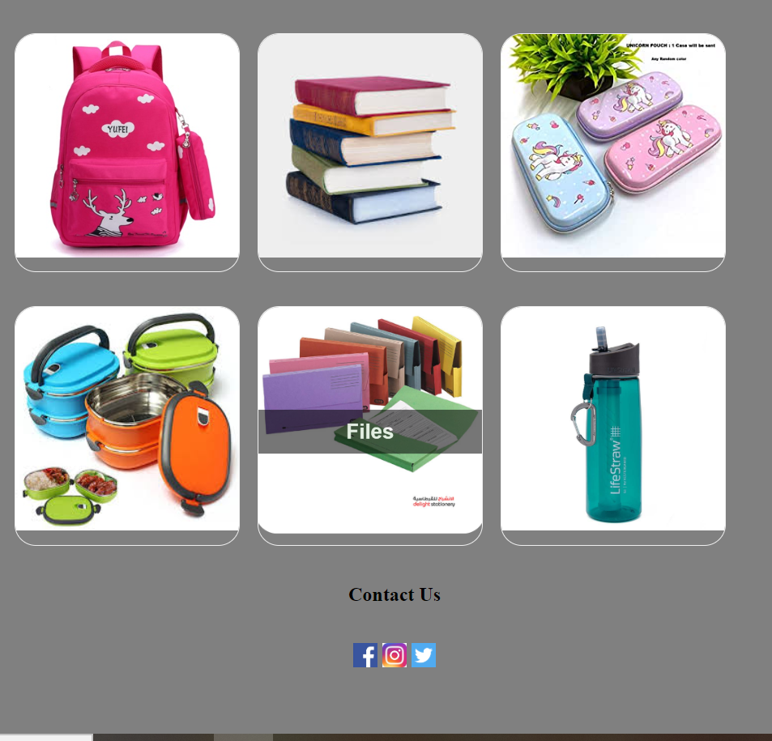



Water Bag

Html coding:-

<!DOCTYPE html>

<html>

<head>

<title> water </title>

<link rel="stylesheet" type="text/css" href="css/water.css">

</head>

<body>

<div class="container">

<div class="water">

<div align="center" class="water1">

<img src="water1.jpg" height="320" width="379"><br><br>

<h5>Water bag </h5>

<h4>

<small><s>500</s></small>

<span>400</span>

</h4>

<input type="button" name="addtocart" value="Add to Cart">

<h3><a href="#"></a></h3>

</div>

</div>

<div class="water">

<div align="center" class="water1">

<img src="water2.jpg" height="320" width="379"><br><br>

<h5> Water bag </h5>

<h4>

<small><s>600</s></small>

<span>550</span>

</h4>

<input type="button" name="addtocart" value="Add to Cart">

<h3><a href="#"></a></h3>

</div>

</div>

<div class="water">

<div align="center" class="water1">

<img src="water3.jpg" height="320" width="379"><br><br>

<h5> Water bag </h5>

<h4>

<small><s>700</s></small>

<span>550</span>

</h4>

<input type="button" name="addtocart" value="Add to Cart">

<h3><a href="#"></a></h3>

</div>

</div>

<div class="water">

<div align="center" class="water1">

<img src="water4.jpg" height="320" width="379"><br><br>

<h5> Water bag </h5>

<h4>

<small><s>600</s></small>

<span>500</span>

</h4>

<input type="button" name="addtocart" value="Add to Cart">

<h3><a href="#"></a></h3>

</div>

</div>

<div class="water">

<div align="center" class="water1">

<img src="water5.jpg" height="320" width="379"><br><br>

<h5> Water bag </h5>

<h4>

<small><s>500</s></small>

<span>440</span>

</h4>

<input type="button" name="addtocart" value="Add to Cart">

<h3><a href="#"></a></h3>

</div>

</div>

<div class="water">

<div align="center" class="water1">

<img src="water6.jpg" height="320" width="379"><br><br>

<h5> Water bag </h5>

<h4>

<small><s>500</s></small>

<span>400</span>

</h4>

<input type="button" name="addtocart" value="Add to Cart">

<h3><a href="#"></a></h3>

</div>

</div>

<div class="water">

<div align="center" class="water1">

<img src="water7.jpg" height="320" width="379"><br><br>

<h5> Water bag </h5>

<h4>

<small><s>500</s></small>

<span>440</span>

</h4>

<input type="button" name="addtocart" value="Add to Cart">

<h3><a href="#"></a></h3>

</div>

</div>

<div class="water">

<div align="center" class="water1">

<img src="water8.jpg" height="320" width="379"><br><br>

<h5> Water bag </h5>

<h4>

<small><s>400</s></small>

<span>350</span>

</h4>

<input type="button" name="addtocart" value="Add to Cart">

<h3><a href="#"></a></h3>

</div>

</div>

<div class="water">

<div align="center" class="water1">

<img src="water9.jpg" height="320" width="379"><br><br>

<h5> Water bag </h5>

<h4>

<small><s>350</s></small>

<span>300</span>

</h4>

<input type="button" name="addtocart" value="Add to Cart">

<h3><a href="#"></a></h3>

</div>

</div>

</div>

</body>

</html>

Css coding:-

body{

margin: 0;

padding: 0;

background-color: grey;

}

.container{

width: 1280px;

height: 900px;

margin: 50px auto 0;

display: flex;

flex-direction: row;

flex-wrap: wrap;

}

.container .water{

position: relative;

width: 370px;

height: 550px;

margin: 15px;

box-sizing: border-box;

display: inline-block;

}

.container .water .water1{

position: relative;

border-radius: 35px;

overflow: hidden;

border:1px solid #eee;

}

.container .water .water1 img{

max-width: 100%;

height: 100%;

width:100%;

transition: transform 2s;

}

.container .water:hover .water1 img{

transform: scale(1.2);

border-radius: 35px;

}

.water{

position:relative;

}

.water h3 a{

position:absolute;

left:0;

top:0;

bottom:0;

right:0;

display:flex;

align-items:center;

justify-content: center;

font-family: arial;

color: #ff0000;

font-size:28px;

background: rgba(0,0,0,0);

opacity: 0;

transform:scale(2);

margin:0;

transition:all 0.5s;

text-decoration: none;

height:36px;

width: 94%;

background: rgba(0,0,0,0);

margin-left:0%;

margin-top:48%;

color: #fff;

border:none;

border-bottom-left-radius:16px;

border-bottom-right-radius:16px;

padding: 3%;

text-align: center;

}

.water:hover h3 a{

opacity: 1;

transform:scale(1);

}

a{

text-decoration: none;

font-size: 16px;

}

a h1{

margin-top: 10px;

margin-right: 35px;

text-align: right;

}

a h1:hover{

color: #ff6666;

}

Output:-

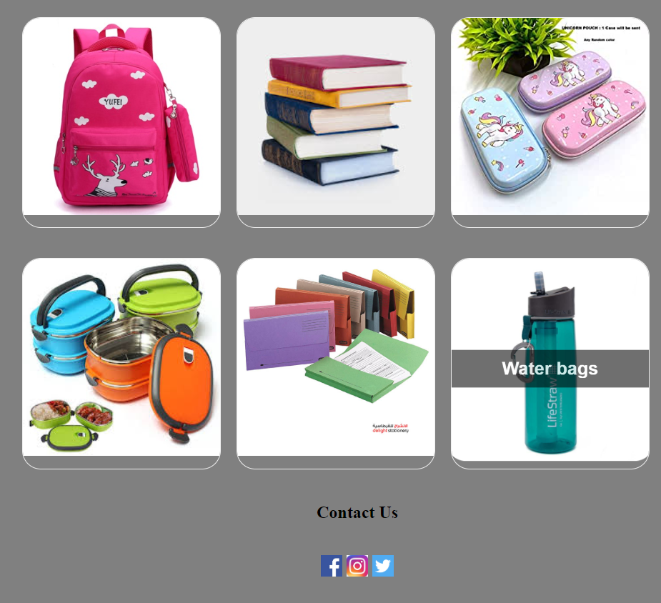

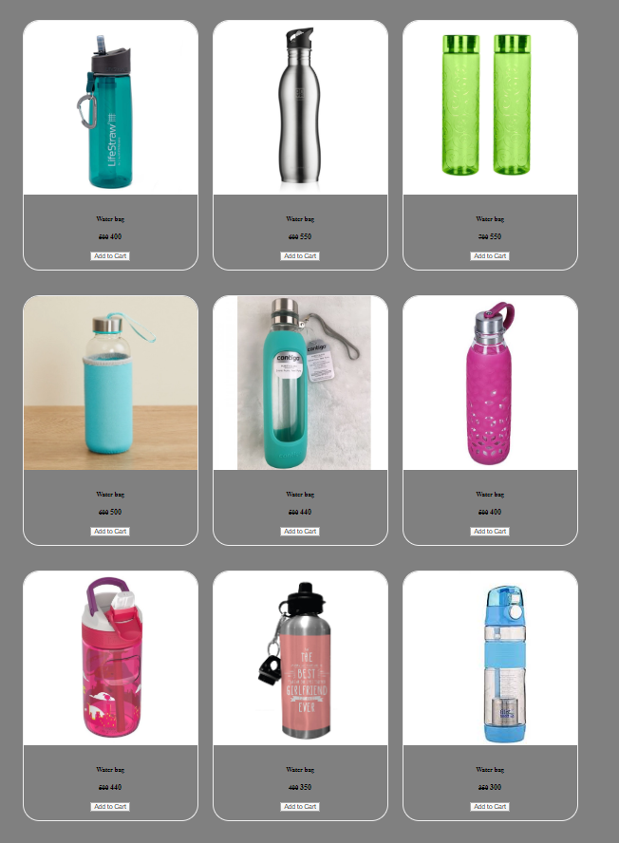

Service

Html coding:-

<html lang="en">

<head>

<title> Service </title>

<link rel="stylesheet" href="css/fontawesome-free-5.12.1-web/css/all.css" />

<link rel="stylesheet" type="text/css" href="css/Service.css">

</head>

<body>

<header>

<div id="navigation">

<nav>

<img src="image/logo1.png" width="200" height="80">

<ul>

<h2>

<li><a href="index.html"> Home </a></li>

<li><a href="Service.html"> Service </a></li>

<li><a href="Our Product.html"> Our Product </a></li>

<li><a href="Contact us.html"> Contact us </a></li>

<li><a href="Registration.html"> Registration </a></li>

</h2>

</ul>

</nav>

</div>

</header>

<div class="Service-section">

<div class="inner-width">

<h1 class="Section-title">Our Service</h1>

<div class="border"></div><br><br><br><br>

<div class="Service-container">

<div class="Service-box">

<div class="Service-icon">

<i class="fas fa-shipping-fast"></i>

</div>

<div class="Service-title">Shipping speeds</div>

<div class="Service-desc"></div>

Eligible shipping speeds and their charges are displayed based on the item(s) in your cart and the delivery address.

</div>

<div class="Service-box">

<div class="Service-icon">

<i class="fas fa-shield-alt"></i>

</div>

<div class="Service-title">trustpay</div>

<div class="Service-desc"></div>

100% Payment Protection. Easy Return Policy. Before accepting shipment of any product, kindly ensure that the product's packaging is not damaged.

</div>

<div class="Service-box">

<div class="Service-icon">

<i class="fas fa-user-lock"></i>

</div>

<div class="Service-title">100% secure payments</div>

<div class="Service-desc"></div>

Moving Your Card details to a much more secured place.

</div>

<div class="Service-box"><br><br><br><br>

<div class="Service-icon">

<i class="fas fa-mobile-alt "></i>

</div>

<div class="Service-title">shop on the go</div>

<div class="Service-desc"></div>

Download the app and get exciting app only offers at your fingertips.

</div>

<div class="Service-box"><br><br><br><br>

<div class="Service-icon">

<i class="fas fa-shopping-bag"></i>

</div>

<div class="Service-title">paytm promise</div>

<div class="Service-desc"></div>

Products with this tag are quality checked, and shipped the same day from certified warehouses. So you get the right product, faster.

</div>

<div class="Service-box"><br><br><br><br>

<div class="Service-icon">

<i class="fas fa-question-circle"></i>

</div>

<div class="Service-title">24x7 help</div>

<div class="Service-desc"></div>

Need Help? Click Here. You can also talk to us on 01204606069 to resolve your query.

</div>

</div><br><br><br><br><br>

</div>

</div>

</body>

</html>

Css coding:-

\*{

margin: 0;

padding: 0;

font-family: sans-serif;

box-sizing: border-box;

}

header{

margin-top: -5px;

padding: 0;

font-family: century Gothic;

}

nav{

width: 100%;

height: 80px;

background-color: #fff;

line-height: 80px;

}

nav ul{

float: right;

margin-top: 0px;

margin-right: 30px;

}

nav ul li{

list-style-type: none;

display: inline-block;

}

nav ul li:hover{

background-color: lightgrey;

transition: 0.8s all;

}

nav ul li a{

text-decoration: none;

color: #000;

font-size: 25px;

padding: 30px;

}

nav img{

margin-left: 3%;

}

.Service-section{

background-color: black;

}

.inner-width{

width: 100%;

max-width: 1200px;

margin: auto;

padding: 0 20px;

overflow: hidden;

}

.Section-title{

text-align: center;

color: #ddd;

margin-top: 15px;

text-transform: uppercase;

font-size: 30px;

}

.border{

width: 200px;

height: 2px;

background: #82ccdd;

margin: 15px auto;

}

.Service-container{

display: flex;

flex-wrap: wrap;

}

.Service-box{

max-width: 33.33%;

padding: 10px;

text-align: center;

color: #ddd;

cursor: pointer;

}

.Service-icon{

display: inline-block;

width: 70px;

height: 70px;

border: 3px solid #82ccdd;

color: #82ccdd;

transform: rotate(45deg);

margin-bottom: 30px;

margin-top: 16px;

}

.Service-icon i{

line-height: 70px;

transform: rotate(-45deg);

font-size: 26px;

}

.Srevice-box:hover .Service-icon{

background: #82ccdd;

color: #ddd;

}

.Service-title{

font-size: 18px;

text-transform: uppercase;

margin-bottom: 10px;

}

.Service-desc{

font-size: 14px;

}

@media screen and (max-width: 768px){

.Service-box{

max-width: 50%;

}

}

@media screen and (max-width: 480px){

.Service-box{

max-width: 100%;

}

}

.back a{

text-decoration: none;

font-size: 16px;

}

.back a h1{

margin-top: 10px;

margin-right: 35px;

color: white;

text-align: right;

}

.back a h1:hover{

color: #39dc79;

}

Output:-

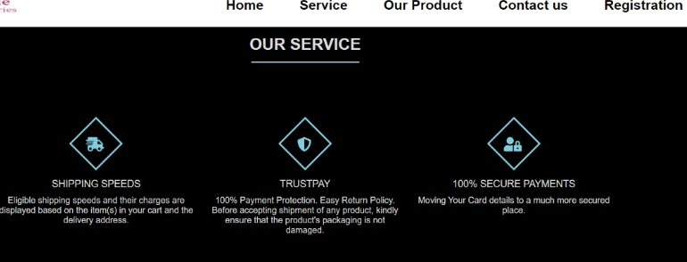



Login & Registration

Html coding:-

<html>

<head>

<title> Registration </title>

<link rel="stylesheet" type="text/css" href="css/Registration.css">

</head>

<body>

<header>

<div id="navigation">

<nav>

<img src="image/logo1.png" width="200" height="80">

<ul>

<h2>

<li><a href="index.html"> Home </a></li>

<li><a href="Service.html"> Service </a></li>

<li><a href="Our Product.html"> Our Product </a></li>

<li><a href="Contact us.html"> Contact us </a></li>

<li><a href="Registration.html"> Registration </a></li>

</h2>

</ul>

</nav>

</div>

</header>

<div class="box">

<div class="form-box">

<div class="button-box">

<div id="btn"></div>

<button type="button" class="toggle-btn" onclick="login()">Log In</button>

<button type="button" class="toggle-btn" onclick="register()">Register</button>

</div>

<div class="social-icons">

<img src="image/facebook.png">

<img src="image/twitter.png">

<img src="image/instagram.jpg">

</div>

<form id="login" class="input-group">

<input type="text" class="input-field" placeholder="@User Id" required>

<input type="text" class="input-field" placeholder="Enter Password" required>

<input type="checkbox" class="check-box"><span> Remember Password</span>

<button type="Submit" class="Submit-btn"> Log In </button>

</form>

<form id="register" class="input-group">

<input type="text" class="input-field" placeholder="First Name" required>

<input type="text" class="input-field" placeholder="Last Name" required>

<input type="text" class="input-field" placeholder="User Id" required>

<input type="email" class="input-field" placeholder="Email Id" required>

<input type="text" class="input-field" placeholder="Enter Password" required>

<input type="checkbox" class="check-box"><span> I agree to the terms & conditions</span>

<button type="Submit" class="Submit-btn"> Register </button>

</form>

</div>

</div>

<script>

var x = document.getElementById("login");

var y = document.getElementById("register");

var z = document.getElementById("btn");

function register()

{

x.style.left = "-400px";

y.style.left = "50px";

z.style.left = "110px";

}

function login()

{

x.style.left = "50px";

y.style.left = "450px";

z.style.left = "0";

}

</script>

</body>

</html>

Css coding:-

\*{

margin: 0;

padding: 0;

}

header{

margin-top: -5px;

padding: 0;

font-family: century Gothic;

}

nav{

width: 100%;

height: 80px;

background-color: #fff;

line-height: 80px;

}

nav ul{

float: right;

margin-top: 0px;

margin-right: 30px;

}

nav ul li{

list-style-type: none;

display: inline-block;

}

nav ul li:hover{

background-color: lightgrey;

transition: 0.8s all;

}

nav ul li a{

text-decoration: none;

color: #000;

font-size: 25px;

padding: 30px;

}

nav img{

margin-left: 3%;

}

.box{

height: 100%;

width: 100%;

background-image: linear-gradient(rgba(0,0,0,0.4),rgba(0,0,0,0.4)),url("image/12.jpg");

background-position: center;

background-size: cover;

position: absolute;

}

.form-box{

width: 400px;

height: 580px;

position: relative;

margin: 5% auto;

background: #fff;

padding: 5px;

overflow: hidden;

}

.button-box{

width: 220px;

margin: 35px auto;

position: relative;

box-shadow: 0 0 20px 9px #ff61241f;

border-radius: 30px;

}

.toggle-btn{

padding: 10px 30px;

cursor: pointer;

background: transparent;

border: 0;

outline: none;

position: relative;

}

#btn{

top: 0;

left: 0;

position: absolute;

width: 110px;

height: 100%;

background: linear-gradient(to right, #ff105f,#ffad06);

border-radius: 30px;

transition: .5s;

}

.social-icons{

margin: 30px auto;

text-align: center;

}

.social-icons img{

width: 30px;

margin: 0 10px;

box-shadow: 0 0 20px 0 #7f7f7f3d;

cursor: pointer;

border-radius: 50%;

}

.input-group{

top: 180px;

position: absolute;

width: 280px;

transition: .5s;

}

.input-field{

width: 100%;

padding: 10px 0;

margin: 5px 0;

border-left: 0;

border-top: 0;

border-right: 0;

border-bottom: 1px solid #999;

outline: none;

background: transparent;

}

.Submit-btn{

width: 85%;

padding: 10px 30px;

cursor: pointer;

display: block;

margin: auto;

background: linear-gradient(to right, #ff105f,#ffad06);

border: 0;

outline: none;

border-radius: 30px;

}

.check-box{

margin: 30px 10px 30px 0;

}

span{

color: #777;

font-size: 12px;

bottom: 68px;

position: absolute;

}

#login{

left: 50px;

}

#register{

left: 450px;

}

a{

text-decoration: none;

font-size: 16px;

}

a h1{

margin-top: 10px;

margin-right: 35px;

color: white;

text-align: right;

}

a h1:hover{

color: #39dc79;

}

Output:-



